Vex Challenge #7:
Pneumatic Forklift

Due Date: Friday
CMU Vex Curriculum: Pneumatics: Using Air Pressure to Perform Work
http://www.education.rec.ri.cmu.edu/roboticscurriculum/vex_online/curriculum/advanced_applications/pneumatics/index.htm
Vex Robotics (http://www.vexrobotics.com): VEX Robotics Pneumatics Parts & Accessories
Vex Forum (http://www.vexforum.com): Search the forum or post questions
Chief Delphi Forum (http://www.chiefdelphi.com): Search the forum or post questions

Use pneumatic actuators to lift tuna cans.

C Level Challenge (70 points):
- Put together a pneumatic testbed:
  - make a cylinder extend and retract (see following picture)
- Draw a diagram of your pneumatic circuit
  - label every item
  - straight lines must be drawn with a ruler
- Program your robot to make the pneumatic cylinder extend and retract (use Chief Delphi)

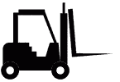
B Level Challenge (85 points):
- Build a robot that can lift/pick up 1 can of tuna
- Program your robot so it can pick up the tuna can
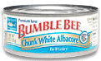
  - Drive your robot up to the can of tuna
  - Pick up the can of tuna
- Make a design drawing of your robot

A Level Hardware Challenge (100 points):
- Build a robot that can lift/pick up 2 cans of tuna
- Program your robot so it can pick up a tuna can and put it down somewhere else

A Level Software Challenge (100 points):
- Program your robot so it can autonomously:
  - Pick up a can of tuna
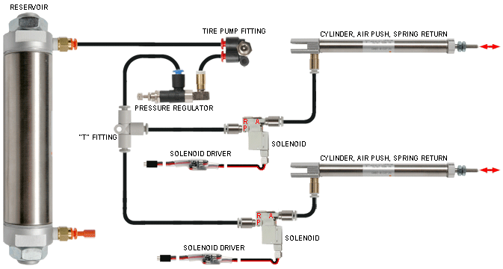
  - Drive forward
  - Drop off the can of tuna
Pneumatic Kit 1- Single Acting Cylinders

