Vex Challenge #5:
Lifts

Due Date: Friday
Vex Inventor’s Guide:
Structure Section: Center of Gravity Considerations (2.27-2.31)
Logic Section: Sensing, Planning, Acting (7.18-7.19)
CMU Vex Curriculum: Sensors: Background Information
http://www.education.rec.ri.cmu.edu/roboticscurriculum/vex_online/programming/sensors/index.htm
Vex Forum (http://www.vexforum.com): Search the forum or post questions
Chief Delphi Forum (http://www.chiefdelphi.com): Search the forum or post questions

Build a robotic lift.

C Level Challenge (70 points):
- Build a robot that uses a single stage lift to extend at least 6 inches upwards
- Make a design drawing of your lift

B Level Hardware Challenge (85 points):
- Build a robot that uses a single stage lift to raise a soda can 10 inches
- Make a design drawing of your arm or lift

B Level Software Challenge (85 points):
- Complete the C Level Challenge
- Implement limit switches to limit the lift’s range of motion in software

A Level Hardware Challenge (100 points):
- Build a robot that uses a two stage lift to raise a soda can 16 inches
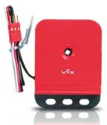
- Make a design drawing of your lift
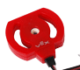
-or-
A Level Software Challenge (100 points):
- Complete the C Level Challenge
- Use a potentiometers or an encoder to detect the height of the lift
- Program buttons on the transmitter to bring the lift to the maximum height, minimum height, and in-between height.
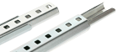
I recommend that you use linear slides.

