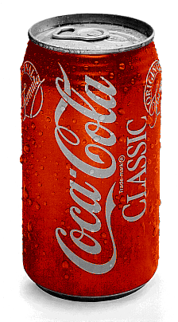
Vex Challenge #3:
Gripper

Due Date: Friday
Vex Inventor’s Guide:
Structure Section: Sturdiness (2.32-2.35), Exposure & Vulnerability (2.36)
Motion Section: Motors and Servomotors (3.3-3.4)
EasyC Help: Search for “servo”

Build a robot that can grab a soda can.

C Level Challenge (70 points):
- Build a robot that uses a servo to grab an empty soda can
  - Drive up to the soda can and grab it
  - Drag the soda can to a designated point
  - Release the soda can and drive away.
- Make a design drawing of your gripper

B Level Hardware Challenge (85 points):
- Build a robot that uses a motorized gripper to grab, drag, and release a full soda can
- Make a design drawing of your gripper

B Level Software Challenge (85 points):
- Build a robot that can complete the C Level Challenge autonomously
  - You will be given the distance between the starting position and the soda can
  - You will be given the distance you need to drag the soda can
  - The robot must return to operator control after releasing the soda can and driving away

A Level Hardware Challenge (100 points):
- Build a robot that uses a roller grip to grab a soda can.
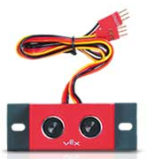
- Make a design drawing of your gripper

A Level Software Challenge (100 points):
- Build a robot that can autonomously detect and collect an empty soda can
- The robot will be placed in the center of a 6’ x 6’ taped square with a soda can
- The robot must turn until it finds the soda can and then go grab the soda can
Use lock-bars to attach metal pieces to axles

