Vex Challenge #1:
Drive Train Design

“A robot’s drive train consists of all of the components used to make the robot move…”
FIRST Wiki

Due Date: Friday
Vex Inventor’s Guide:
Structure: squarebot chassis pats and assembly (2.2-2.26)
Programming: using the radio control transmitter (8.45-8.46)
CMU Vex Curriculum: Hardware
http://www.education.rec.ri.cmu.edu/roboticscurriculum/vex_online/hardware/index.htm#
FIRST Wiki: Drivetrain
http://www.firstwiki.net/index.php/Drivetrain

Build a robot to drive around the classroom.

C Level Challenge (70 points):  - Make a sketch  - Build a robot with skid (tank) steering  - i.e. all wheels always point in the same direction  - Download the Default Code  - Make a design drawing | 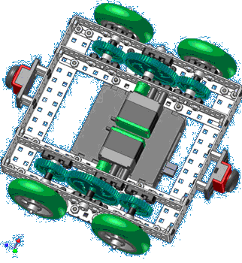
B Level Challenge (85 points):  - Make a sketch  - Build a robot with swerve drive  - i.e. the wheels have to be steerable  - Write a program to drive your robot  - Make a design drawing | 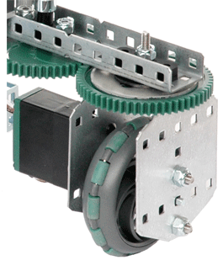
A Level Challenge (100 points):  - Make a sketch  - Build a robot with holonomic (omni) drive  - i.e. omni-wheels that turn in different directions so the robot can drive in any direction  - Write a program to drive your robot  - Make a design drawing | 