Vex Challenge #0:
Testbed

“A testbed is a platform for experimentation …”
Wikipedia
Due Date: Friday
Vex Inventor’s Guide:
Motion: Motors & Servomotors (3.3-3.4)
Programming: programming hardware setup (8.13), download the test code (8.14-8.18), using online code to test your robot (8.21)
CMU Vex Curriculum: Test the Kit
http://www.education.rec.ri.cmu.edu/roboticscurriculum/vex_online/hardware/index.htm#

C Level Challenge (70 points):  - Put together a testbed including:  - 1 robot controller  - 1 receiver  - 2 motors  - 2 wheels (attached to motors)  - 1 rechargeable battery  - Download the most recent Master Code  - Download the Test Code  - Test to see if your motors work properly |   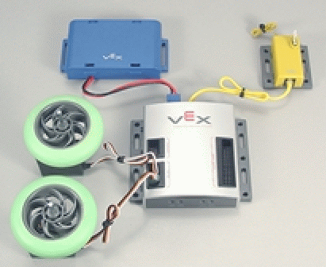
B Level Challenge (85 points):  - Complete the C Level Challenge  - Add two servomotors to your testbed  - Download the On-Line Code  - Use the On-Line Window to:  - move the motors  - move the servos | 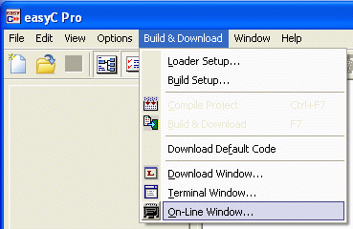
A Level Challenge (100 points):  - Complete the B Level Challenge  - Write a program so:  - servos move in opposite directions  - motors turn continuously in opposite directions for 2 seconds | 