Name: __________________________
Date: ___________________________

Electromagnetic Waves

- (1 pt) The energy of an electromagnetic wave depends on _________________.

- (1 pt) What is the speed of all electromagnetic waves? ____________________

- Fill in the blanks.
Jet speed = 0 m/s
(1 pt) Speed of light = ___________________
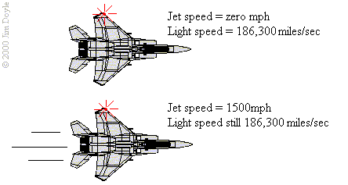
Jet speed = 900 m/s
(1 pt) Speed of light = ___________________
Parked Jet
Flying Jet
light
light
- (2 pts) The alternating current (AC) in the wall oscillates at 60 Hz. AC current moves at the speed of light. What is the wavelength of the waves of electricity?

- (2 pts) Draw an electromagnetic wave.

- (2 pts) How does changing an electric field make an electromagnetic field?

- Pretend Jenaye’s bus is a wave.
  - (2 pts) What is the speed of Jenaye’s bus if it has a frequency of 4.7 Hz and a wavelength of 11 m?

  - (2 pts) How much energy does Jenaye’s bus have?

- (2 pts) Jerrell decides to take up surfing. He rides a wave with a wavelength of 5.63 m at a speed of 4.2. What is the frequency of the wave?

- Blue light has a frequency of 7.5 x 10¹⁴ Hz.
  - (2 pts) What is the wavelength of blue light?

  - (2 pts) The quantum theory of light says that light is radiated and absorbed in little bits called photons. How much energy does a photon of blue light have?

- The wavelength of red light is 7.9 x 10⁻⁷m.
  - (2 pts) What is the frequency of red light?

  - (2 pts) How much energy does a photon (the smallest bit) of red light have?

- (2 pts) Marcus tunes his radio to 92 Q which has a frequency of 92,300 Hz. What is the wavelength of 92 Q?

- (2 pts) What is the principle of superposition? Hint: look in the glossary or the index.

- (2 pts) Can electromagnetic waves interfere with each other? Explain.

- (1 pt) Who was the first American to win a Nobel Prize in science?

