Name: __________________________
v
f
λ he Doppler Effect

Date: ___________________________

The Doppler Effect

Questions 1 & 2 refer to the following diagram:
Police Car & Siren
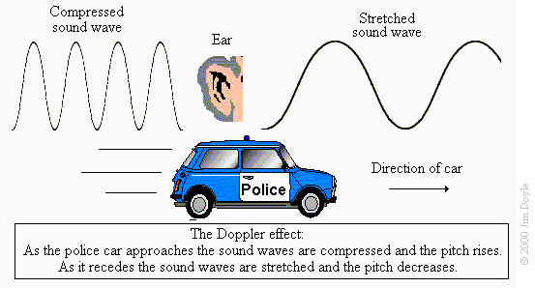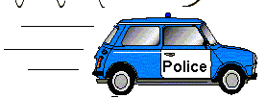
Delano
Justin
Stretched Wave
Compressed Wave
Sound Source

- (1 pt) Who will hear a higher pitched sound?

- (1 pt) When the car passes Justin will he hear the sound get higher or lower?

- (1 pt) As the pitch of a sound gets lower, does the frequency of the sound waves increase, decrease, or remain unchanged?

- (2 pt) When the police car isn’t parked and the frequency of the sound from the siren is 4325 Hz and the wavelength is 0.080 m. What is the speed of sound?

Use the speed of sound from question 4 to answer questions 5 & 6.
- (2 pt) The wavelength of the sound waves that Ricardo heard was 0.090 m. What was the frequency?

- (2 pt) Justin heard the same waves as Ricardo, but he heard a frequency of 4942 Hz. What was the wavelength of the waves that Justin heard?

- (1 pt) As the frequency of a sound wave increases does the pitch become higher, lower, or stay the same?

- (1 pt) How are frequency and wavelength related?

- (1 pt) As pitch increases does the wavelength become longer, shorter, or stay the same?

Questions 10-15 refer to the following pair of diagrams:
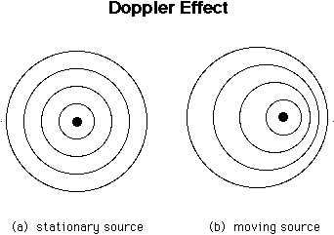
______________ Wave Source
______________ Wave Source
Left
Right

- (1 pt) Label the diagrams (Hint: one wave source is moving, and the other is stationary).

- (1 pt) Draw an arrow pointing in the direction where the moving wave source is going.

- (1 pt) On which side (left or right) of the moving wave source is the wavelength the longest?

- (1 pt) On which side (left or right) of the moving wave source is the wavelength the shortest?

- (1 pt) On which side (left or right) of the moving wave source is the frequency the highest?

- (1 pt) On which side (left or right) of the moving wave source is the frequency the lowest?

- Joy and Erica are half a block away from each other when they both hear a noisy old car speeding down Orleans St.
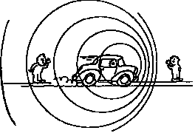
  - (1 pt)Who hears longer wavelength sound waves?
Erica
Joy
(Joy, Erica, or neither)
  - (1 pt) Who hears lower frequency sound waves?
(Joy, Erica, or neither)
  - (1 pt) Who hears the highest pitched sound?
(Joy, Erica, or neither)
  - (1 pt) Who hears the lowest pitched sound?
(Joy, Erica, or neither)
  - (1 pt) Who do the sound waves come to the fastest?
(Joy, Erica, or neither)

- (1 pt) If the wavelength of a wave gets longer does the frequency increase or decrease?

- A 2 Hz wave source (the dot) makes waves in a pan of water. Each line represents the crest of a wave.
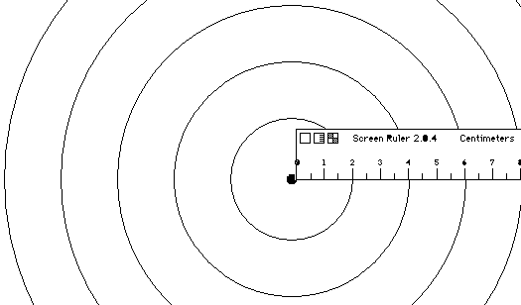

A
B
E
D
C

  - (1 pt) Which ripple (A, B, C, D, E) was generated first?

  - (1 pt) Which ripple (A, B, C, D, E) was generated last?

  - (1 pt) What is the wavelength of the waves?
Hint: use the ruler in the picture.

  - (2 pt) What is the speed of the waves?

  - (1 pt) How many ripples are generated each second?

  - (1 pt) How old is ripple E?

  - (1 pt) How old is ripple C?

- Draw a wave diagram of a wave source moving in the direction of the arrow.
  - (1 pt) Put an X where an observer would hear a high pitched sound.
  - (1 pt) Put an O where an observer would hear a low pitched sound.

