Name: __________________
Date: ___________________

The Doppler Effect for Light
We know that the speed of the light stays the same so it must be the wavelength and therefore the frequency that changes. This manifests itself as a change in the color of the light. The change is far too small to be seen with the naked eye, but quite easy to detect using electronic equipment, such as a radar gun.
As a light wave approaches us its frequency is "shifted" towards the blue part of the spectrum. That is, if the light was white to begin with it will now have its wavelength compressed in such a way that it begins appear blue. Likewise, if the light is moving away from us it will appear red because its wavelength is stretched and its frequency is correspondingly lower than before. It is only when the light source is stationary that we can see what color it really is.
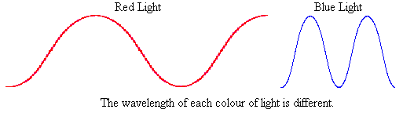
We can use the Doppler effect of moving light sources to establish something quite extraordinary about the speed of light, and the universe.
Questions:

- A rocket ship full of aliens is coming towards earth. To us, their green lights would appear shifted towards what color?

- A distant galaxy sends the light of a billion stars towards earth. Astronomers on earth note that the light of all the stars is redder than the light of the sun. Is the galaxy coming closer or getting further away?

- A cop uses a radar gun to bounce light off a speeding car. The light comes back blue shifted. Was the car approaching the cop or speeding past the cop?

For questions 4-6: The following table shows what color different wavelengths appear as.

Abbreviation | Color | Wavelength (λ)
R | Red | 720 nm ↔ 640 nm
O | Orange | 640 nm ↔ 600 nm
Y | Yellow | 600 nm ↔ 560 nm
G | Green | 560 nm ↔ 500 nm
B | Blue | 500 nm ↔ 420 nm
V | Violet | 420 nm ↔ 400 nm

- A theatrical spotlight makes electromagnetic waves with a wavelength of 421 nm.
  - What color is the spotlight?

  - If the spotlight was moving away what color would the light shift too?

- Latonya, a forensic scientist examines a poorly lit video of a drive by shooting. Using a spectroscope she notices that the muzzle flashes are redder than those produced by a stationary shooter.
- Was the car coming closer or speeding away when the shooting occurred?

- Latonya measured the wavelength to be 703 nm. Would the wavelength have been longer or shorter if the shooter had been standing still?

- The light from sodium vapor street lights has a frequency of 4.70 x 10¹⁴ Hz.
  - What wavelength is the light?

  - What color are sodium vapor street lights?

- A firefly emits light with a wavelength of 598 x 10⁻⁹m.
  - What color is the firefly’s light?

  - If the firefly were to fly away really fast, what color might the firefly’s light appear?

- Kita’s bug zapper emits light at a wavelength of 409 nm.
  - What frequency is the light from the bug zapper?

  - What color is Kita’s bug zapper?

- The light from a neon sign outside Andrea’s favorite pizza place has a frequency of 7.48 x 10¹⁴ Hz.
  - What wavelength is the light?

  - What color is the neon sign?
Questions 10-14 refer to the following picture.
Stars and galaxies (made up of stars) emit the same wavelengths of light. If they weren’t moving they would all appear to be the same color. However if they are moving the wavelengths are shifted and they appear to be different colors. The faster they move, the bigger the shift. Each black line represents a color that we observe coming from a star or galaxy.

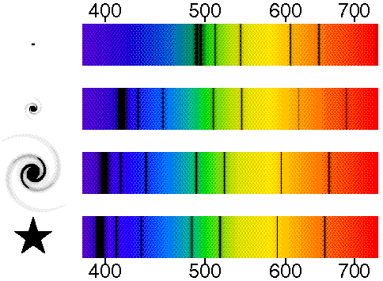
A really faraway galaxy
A faraway galaxy
A nearby galaxy
The sun
nm
nm
nm
nm
nm
nm
nm
nm

- What color is on the left with a wavelength of 400 nm?

- What color is on the right with a wavelength of 700 nm?

- The light from which galaxy is shifted the most?
Hint: the light from the sun won’t be shifted at all.

- As you get farther from the sun are the galaxies moving faster, slower, or the same speed?

- Is the light from the faraway galaxy shifted in the red direction or in the blue direction?

- Are the other galaxies coming closer to the sun (and us) or moving further away?

- Is the universe expanding or contracting?

