Name: _____________________
Date: ______________________

Classifying Waves

- What is a wave?

- The following diagram shows a wave pulse moving through a coiled spring (like a slinky).

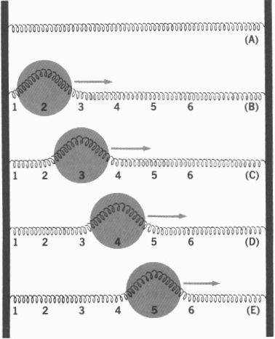
  - Which direction (left or right) is the disturbance moving in?

  - Is this an example of a pulse wave or of a periodic wave?

  - Is the disturbance parallel or perpendicular to the direction the wave is traveling?

  - What kind of wave does this diagram show?

  - Do any of the points (1, 2, 3, 4, 5, or 6) ever move left to right?

- The following picture is of another wave in a coiled spring.
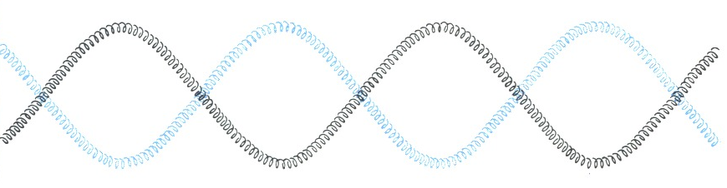
  - Does the disturbance move perpendicular or parallel to the direction that the wave is traveling in?

  - Is this an example of a transverse or longitudinal wave?

  - Is this an example of a wave pulse or of a periodic wave?

- The following picture is of another wave in a coiled spring.
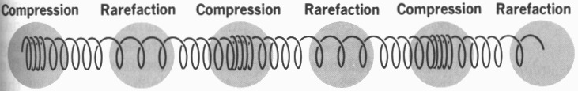

  - Does the disturbance move perpendicular or parallel to the direction that the wave is traveling in?

  - Is this an example of a transverse or longitudinal wave?

  - Is this an example of a wave pulse or of a periodic wave?

  - Make up a definition for a compression.

  - Make up a definition for a rarefaction.

- Use Figure A and Figure B to answer the following questions.
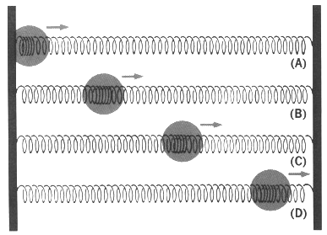 | 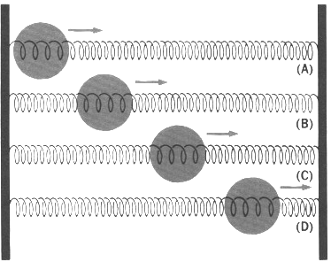
Figure A | Figure B

  - Figures A and B are both examples of what kind of wave?

  - Are the disturbances in Figure A compressions or rarefactions?

  - Are the disturbances in Figure B compressions or rarefactions?

