Name: ___________________ Adding Vectors Graphically Date: ______________
0˚
Find the resultant vector graphically. Give the magnitude in cm and the direction in degrees.
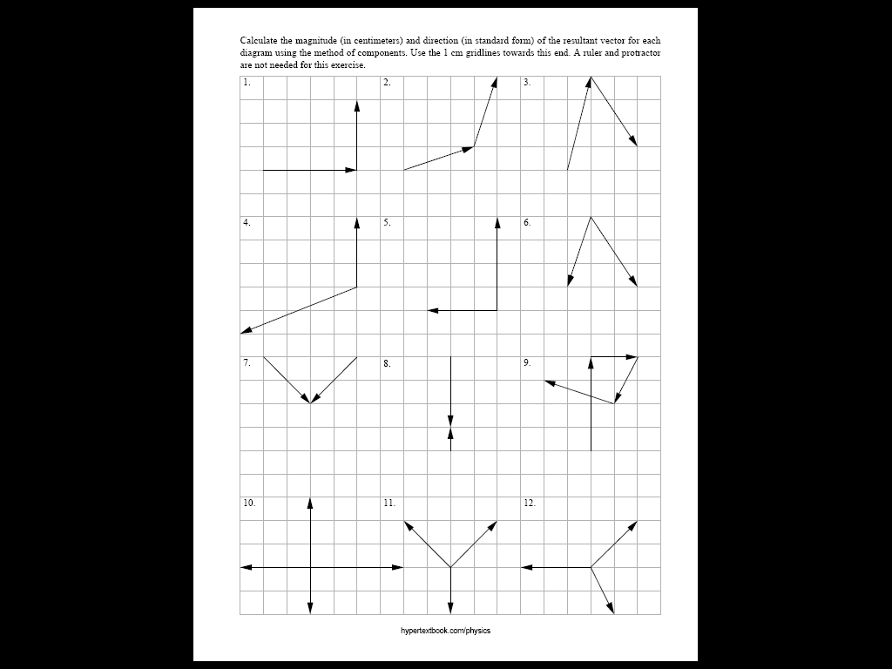

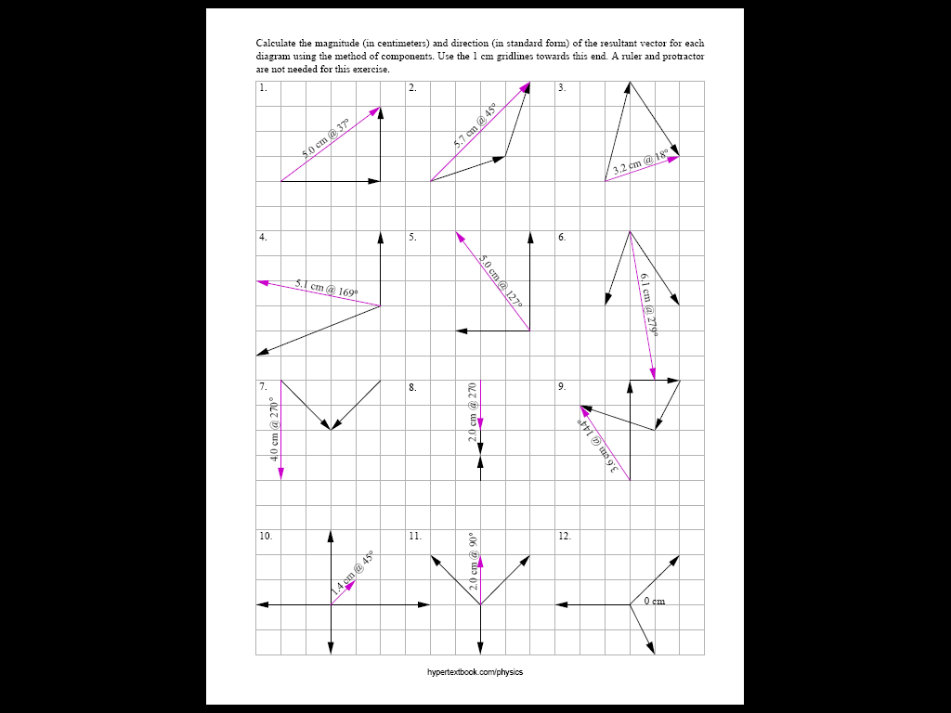
Adding Vectors Graphically: KEY
correction: 3.6 cm
@ 124ْ

