Mr. Gabrielse | Date: 2/17/2006

- Unit: Pressure
Topic: Bernoulli’s Principle
______________________________________________________________________________
B. MSDE and BCPSS Standards

CLG 5.1.1: Use analytical techniques appropriate to the study of physics

CLG 5.1.4: Analyze the behavior of forces.

CLG 5.7.2: The student will recognize the important role that mathematics serves when solving problems in physics.
______________________________________________________________________________
C. Lesson Objectives:
- Students will know Bernoulli’s principle and do problems.
______________________________________________________________________________
D. Opening Activity/Drill
- Drill:
- Which pressure principle has to do with floating?
Archimedes principle
- Which pressure principle has to do with fluids in containers?
Pascal’s principle
- What happens to pressure if the force on an object doubles while the area doubles as well?
Nothing: doubling the force doubles the pressure, but doubling the area halves the pressure.

  - Go over the answers in class

Modifications: The drill will be on the board and read orally. Extra processing time and additional teacher assistance will be provided.
______________________________________________________________________________
E. Development
- Immediate Feedback: p. 323: 17, p. 324: 40
17 (3 pts): Area got smaller so pressure increased
40 (2 pts for F_{buoyancy}, 2 pts for F_{lift}, 1 pt for units):
F_{buoyancy} = D_{air}Vg = (1.20 kg/m³)(1.00m³)(9.80m/s²) = 11.76 N
F_{g} = m_{helium}g = D_{helium}Vg = (0.177 kg/m³)(1.00m³)(9.80m/s²) = 1.73 N
F_{lift} = F_{buoyancy} – Fg = 11.76 N - 11.76 N = 10.0 N

- Engagement of Students
  - Think Time: What force holds airplane’s up in the sky?

Modifications: Extra processing time and additional teacher assistance will be provided.
______________________________________________________________________________
- Exploration Activities
  - What happens when you blow over the top of a piece of paper?
  - Why?

Modifications: Students may work with partners.
______________________________________________________________________________
- Explanation

- Bernoulli’s Principle: the velocity and pressure of a fluid are inversely proportional
  - As the velocity of a fluid increases the pressure exerted by that fluid decreases
    - Example: Blow over a piece of paper and it rises.
      - Over the paper the velocity is higher so the pressure is lower.
      - The paper is pushed up by the bigger pressure below the paper.

v
P
P
V

- Incorrect Lift Theory (You don’t need to take notes)
  - Argument:
    - The shape of airplane wings is designed to take Bernoulli’s principle into account.
    - Air has to travel faster over the top of the wing since the top is curved.
    - So there is less pressure on top of the wing.

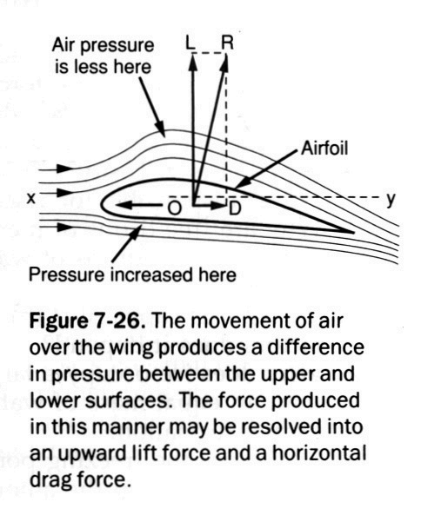
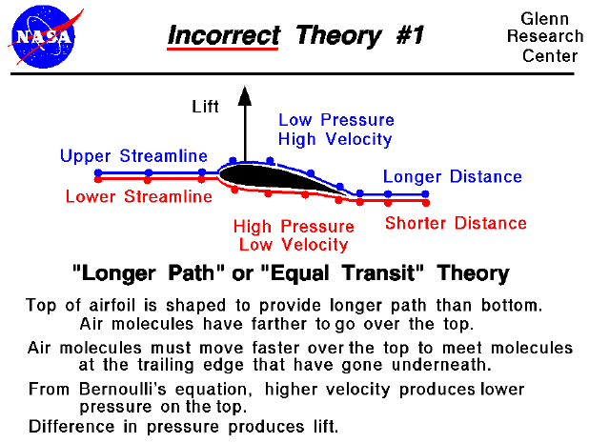

Modifications: The notes will be projected and reviewed orally. The notes are also available for the students to copy after school (Monday, Wednesday, Thursday, & Friday or by special arrangement).
______________________________________________________________________________
- Extension
  - Turning is what counts.
    - Total momentum of air before plane comes along is zero.
    - The wing gives some air downward momentum (turning).
    - Total momentum must stay zero so the airplane gets as much upward momentum as the plane got downward momentum.
  - Java Applet: Lift of Wright Aircraft
  - Start your homework early.

Modifications: Students will be encouraged to work with partners. Teacher assistance is also available.
______________________________________________________________________________
- Evaluation/Assessment
  - The homework will be collected and graded tomorrow.

Modifications: Teacher notes are available for copying after school if required. Students who need help reading will be assigned a partner.
______________________________________________________________________________
- Closure
  - Is air pressure important?
______________________________________________________________________________
- Home Assignment
  - Study Guide: p. 74 & 75
  - EC: Why can airplanes fly upside down?
  - Study for the test.
There are many theories of how lift is generated. Unfortunately, many of the theories found in encyclopedias, on web sites, and even in some textbooks are incorrect, causing unnecessary confusion for students.
The theory described on this slide is one of the most widely circulated, incorrect explanations. The theory can be labeled the "Longer Path" theory, or the "Equal Transit Time" theory. The theory states that airfoils are shaped with the upper surface longer than the bottom. The air molecules (the little colored balls on the figure) have farther to travel over the top of the airfoil than along the bottom. In order to meet up at the trailing edge, the molecules going over the top of the wing must travel faster than the molecules moving under the wing. Because the upper flow is faster, then, from Bernoulli's equation, the pressure is lower. The difference in pressure across the airfoil produces the lift.
Before considering what is wrong with this theory, let's investigate the actual flow around an airfoil by doing a couple of experiments using a Java simulator which is solving the correct flow equations. Below the simulator is a text box with instructions. Be sure that the slider on the right of the text box is pulled to the top to begin the experiments
This interactive Java applet shows flow going past a symmetric airfoil. The flow is shown by a series of moving particles. You can change the angle of attack of the airfoil by using a slider, and the angle of attack generates the lift through flow turning. There is also a translating probe with a gage on the simulator which lets you investigate the flow.
This is a secondary Java applet which uses a text box to describe some experiments for the student to perform using the previous applet.
Let's use the information we've just learned to evaluate the various parts of the "Equal Transit" Theory.
- {Lifting airfoils are designed to have the upper surface longer than the bottom.} This is not always correct. The symmetric airfoil in our experiment generates plenty of lift and its upper surface is the same length as the lower surface. Think of a paper airplane. Its airfoil is a flat plate --> top and bottom exactly the same length and shape and yet they fly just fine. This part of the theory probably got started because early airfoils were curved and shaped with a longer distance along the top. Such airfoils do produce a lot of lift and flow turning, but it is the turning that's important, not the distance. There are modern, low-drag airfoils which produce lift on which the bottom surface is actually longer than the top. This theory also does not explain how airplanes can fly upside-down which happens often at air shows and in air-to-air combat. The longer surface is then on the bottom!
- {Air molecules travel faster over the top to meet molecules moving underneath at the trailing edge.} Experiment #1 shows us that the flow over the top of a lifting airfoil does travel faster than the flow beneath the airfoil. But the flow is much faster than the speed required to have the molecules meet up at the trailing edge. Two molecules near each other at the leading edge will not end up next to each other at the trailing edge as shown in Experiment #2. This part of the theory attempts to provide us with a value for the velocity over the top of the airfoil based on the non-physical assumption that the molecules meet at the aft end. We can calculate a velocity based on this assumption, and use Bernoulli's equation to compute the pressure, and perform the pressure-area calculation and the answer we get does not agree with the lift that we measure for a given airfoil. The lift predicted by the "Equal Transit" theory is much less than the observed lift, because the velocity is too low. The actual velocity over the top of an airfoil is much faster than that predicted by the "Longer Path" theory and particles moving over the top arrive at the trailing edge before particles moving under the airfoil.
- {The upper flow is faster and from Bernoulli's equation the pressure is lower. The difference in pressure across the airfoil produces the lift.} As we have seen in Experiment #1, this part of the theory is correct. In fact, this theory is very appealing because many parts of the theory are correct. In our discussions on pressure-area integration to determine the force on a body immersed in a fluid, we mentioned that if we know the velocity, we can obtain the pressure and determine the force. The problem with the "Equal Transit" theory is that it attempts to provide us with the velocity based on a non-physical assumption as discussed above.

Pressure Notes (Continued):
- Bernoulli’s Principle: the velocity and pressure of a fluid are inversely proportional.
  - As the velocity of a fluid increases the pressure exerted by that fluid decreases
    - Example: Blow over a piece of paper and it rises.
      - Over the paper the velocity is higher so the pressure is lower.
      - The paper is pushed up by the bigger pressure below the paper.

v
P
P
V

