To: All Engineers in Physics
Re: Air Drop Packaging System

The government is currently accepting bids on a contract to air drop fragile medical supplies into Iraq. Our company stands to benefit if we can secure the contract. Accordingly, all engineers are to begin work designing packaging systems. In order to minimize expenses, all internal testing will be conducted using grade A eggs (see: Notes on Grade A Eggs) to simulate the fragile medical supplies. All engineers who successfully meet the design challenges will be rewarded. Essential information and instructions are forthcoming.

Sincerely,

J. Gabrielse, CEO

Notes on Grade A Eggs:

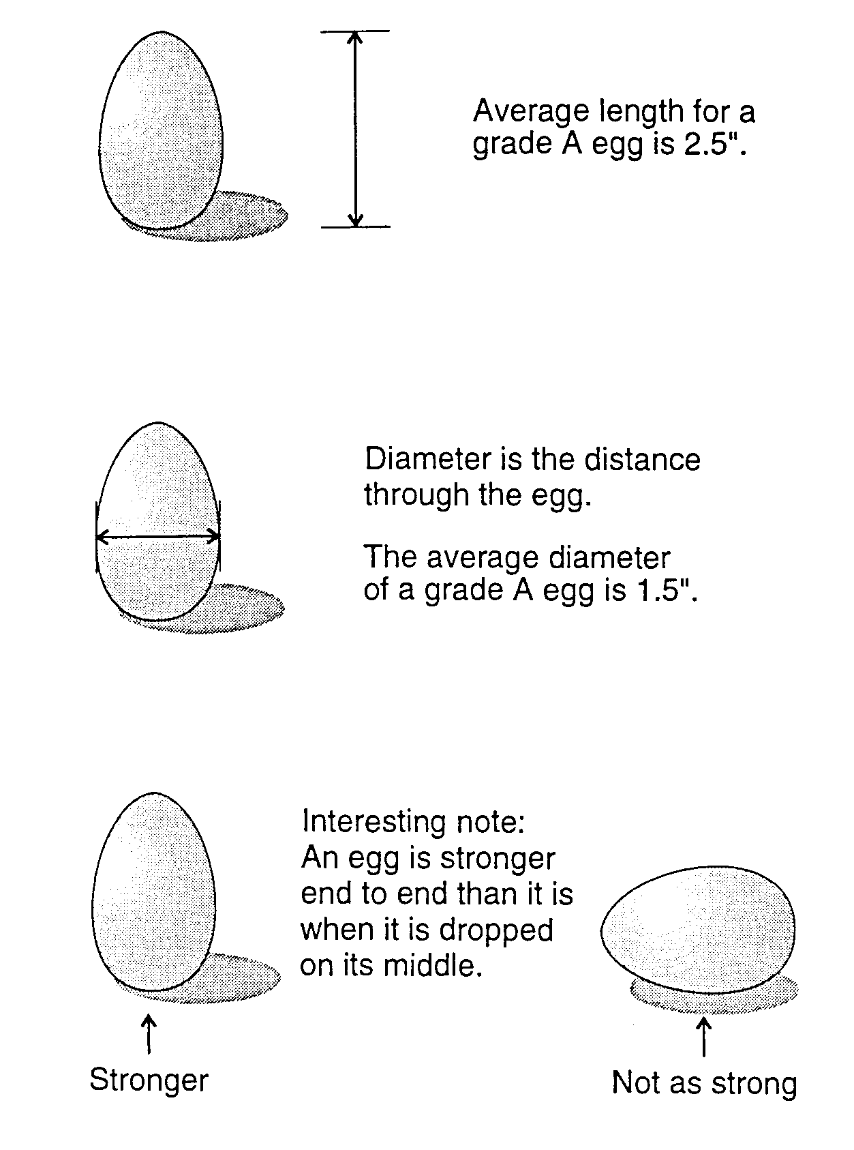
Name: __________________________
Date: ___________________________

Egg Drop: Rubric

Diagram/Picture (15 pts):
- The picture is on a separate sheet of paper
- Lines are drawn with a ruler
- All materials are labeled

Construction (20 pts):
- Sturdy
- Neat
- Creative/Original
- The egg can be removed in between tests

Design Requirements (15 pts):
- Your design does not use a parachute.
- The entire package fits inside the sizing box.
- The entire package (including egg) is less than 300 g

Test (20 pts):
- (10 pts) The egg survives a two story fall.
- (10 pts) The egg survives a one story fall.
- (+10 pts) Bonus Drop: The egg survives a fall from the top of the stairwell.

Explanation (30 pts):
- at least ½ page of text on a separate sheet of paper
- describes the design
- explains how the design is supposed to work in terms of force, area, and pressure

Prize:
- The class with the best egg-drop record wins breakfast (juice and donuts)

 | VS. | 