Name: ______________ Partner: ________________ Partner: ________________
Date: _______________

Spark Timer Lab

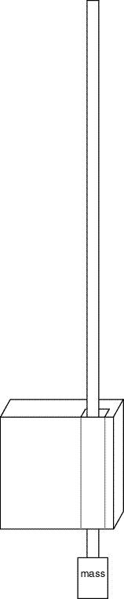
Purpose: Measure the acceleration due to gravity, g, in the classroom.

Overview:
- Use a spark timer to make a motion diagram on a strip of paper attached to a falling mass.
- Calculate the acceleration due to gravity, g, from the motion diagram.

Materials:
1 spark timer
1 strip of special paper for the spark timer
1 mass
1 meter stick

Procedure:
- Set your spark timer to 10 Hz. This means that the timer will spark once every 0.1 s.
- Attach a mass to your strip of paper.
- Before turning the timer on: practice letting the mass pull the paper through the spark timer.
- Set the timer up so the falling mass will pull the paper through the spark timer.
- Turn the spark timer on.
- Let the mass pull the paper through the spark timer.
- Only use the last 6 pairs of dots made on your strip of paper.
- Measure the distance (Δd) between each pair of dots to the nearest tenth of a centimeter.
- Record your measurements for Δd in the data table.
- Record Δt for each measurement.
  - Δt is the time between each spark.
- Calculate the average velocity for each time interval.
  - Remember: $\bar{v}=\frac{\text{Δd}}{\text{Δt}}$
- Calculate the average acceleration between each time interval.
  - Remember: $\bar{a}=\frac{\text{Δv}}{\text{Δt}}=\frac{{\bar{v}}_{\text{end}}−{\bar{v}}_{\text{begin}}}{\text{Δt}}$
- Average all your accelerations to get the average acceleration for the whole experiment.
  - Remember: to find averages add up each and divide by the number of things you added.

Data & Calculations:
Δd | Δt | $$\bar{v}$$ | $$\bar{a}$$
 |  |  | NA

Conclusions: Use a separate sheet of paper to answer the following questions in paragraph form. Please staple your conclusions to the back of this sheet when finished.
- What was the average acceleration due to gravity that you measured?
- Why do you think you didn’t measure exactly 9.80$\frac{m}{s^{2}}$?

