Name: ___________________ Partner: ___________________
Date: ____________________ Computer: _________________

Measuring Acceleration Due to Gravity

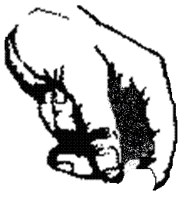
motion sensor
ball bearing
bench top

Procedure:
- Setup the motion sensor as pictured.
- Press collect on the computer.
- When the motion sensor starts ticking, drop the ball bearing.
- Record your data in the data table.
- Repeat 3 times.

Data:

 | t₀ | t₁ | v₀ | v₁
Trial 1
Trial 2
Trial 3

Calculations:
- What is the average acceleration due to gravity during Trial 1?

- What is the average acceleration due to gravity during Trial 2?

- What is the average acceleration due to gravity during Trial 3?

- What was the average acceleration due to gravity that you measured?
Hint: average the average accelerations for trials 1, 2 and 3.

Conclusions:

- How much did average acceleration vary over your three trials?

- How does your average, average acceleration compare to the accepted value of 9.80$\frac{m}{s^{2}}$?

- Explain why you didn’t measure exactly 9.80$\frac{m}{s^{2}}$.

