Name: __________________________
Date: ___________________________

Position vs. Time Graphs

Time (s) | Position (m) | 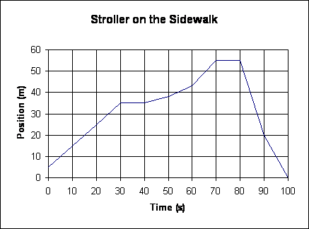
0 | 5
10 | 15
20 | 25
30 | 35
40 | 35
50 | 38
60 | 43
70 | 55
80 | 55
90 | 20
100 | 0
Give answers as one or more time intervals. Ex: 10s – 20s, 50s – 90s
- (2 pts) When was the stroller moving in the negative direction?

- (2 pts) When was the stroller moving in the positive direction?

- (4pts) When was the stroller moving in the positive direction at a constant velocity? What was its speed?

- (2 pts) When was the stroller stopped?

- (2 pts) When was the stroller speeding up?

- (4 pts) When was the stroller moving the fastest? What was its speed?

- (2 pts) Sketch a position vs. time graph for a skateboarder gliding along the sidewalk at a constant speed in the positive direction. | - (2 pts) Draw a position vs. time graph for a bicycle as it slows down while going up a hill.
- (2 pts) South is the positive direction. north is the negative direction. Sketch a position vs. time graph for Rhodneisha. She drives north from Baltimore towards Philadelphia at a constant 75 mph. | - (2 pts) Sketch a position vs. time graph for Ms. Wiggs. She leaves her office (the negative direction) and slowly walks towards the main office (the positive direction). She stops to talk and then quickly walks back to her office.
- (2 pts) Sketch a position vs. time graph for a ball accelerating down a hill. Up is positive and down is negative. | - (2 pts) Draw a position vs. time graph for an elephant starting from rest and charging a palm tree.

