Name: __________________________
Date: ___________________________

Kinetic Energy

- James’ water rocket is stuck in a tree. Rodney’s water rocket is sitting on the launch pad. Which bottle rocket has more gravitational potential energy and why?
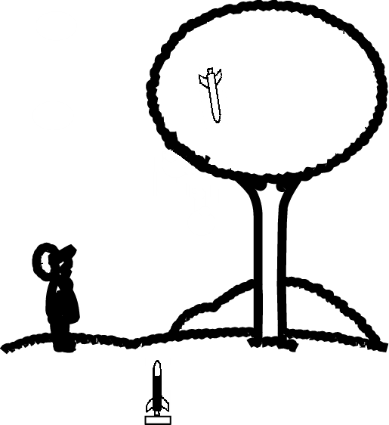
- If m = 901 kg and h = 43 m, what is the gravitational potential energy?

- If m = 16 kg and h = 2.37 km, what is the gravitational potential energy?

- Erin throws a 213 g softball straight into the air. The softball goes up 82 m before it stops going up and starts to fall. What is the maximum gravitational potential energy of the softball?

- If m = 26.2 kg and v = 0.47, what is the kinetic energy, K?

- The mass is 12 kg and the velocity is 0.6. What is the kinetic energy?

- If v = 4.9 and m = 340 kg what is the kinetic energy, K?

- What is the kinetic energy of Jody’s 4 kg skateboard when it is moving at 12.8?

- If Antonio’s 3.2 kg helmet is flying through the air at 20.1, what is its kinetic energy?

- A .44 caliber slug (a big bullet) has a mass of about 0.05 kg. If a bullet moves at 300, what is the kinetic energy of a .44 caliber slug?

- A 0.25kg water rocket moves at 13.6. What is the kinetic energy of the water rocket?

- If the kinetic energy of a cop car is 3400 J while the car is moving at 10, what is the mass of the cop car (the units will be kilograms)? Hint: $m=\frac{\text{2K}}{v^{2}}$

- The kinetic energy of an Olympic skier is 3100 J. If the skier’s velocity is 23, what is their mass (the units will be kilograms)?

- Water molecules in a cup of hot (56° C) tea move with an average velocity of 54. The mass of the water in the cup is 0.35 kg. How much kinetic energy is in one cup of hot tea?

