Name: __________________________
Date: ___________________________

Gravitational Potential Energy

- What is the equation for gravitational potential energy?

- James’ water rocket is stuck in a tree. Robert’s water rocket is sitting on the launch pad. Which bottle rocket has more gravitational potential energy and why?

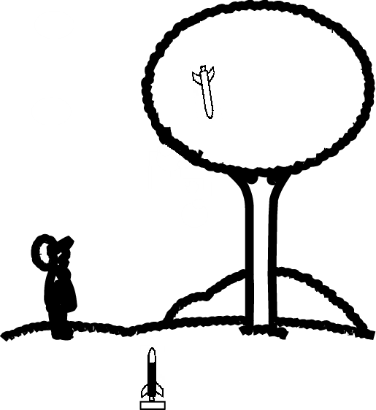

- If m = 901 kg and h = 43 m, what is the gravitational potential energy?

- If m = 16 kg and h = 2374 m, what is the gravitational potential energy?

- If h = 0.75 m and m = 1020 kg, what is the gravitational potential energy?

- Erin throws a 200 g softball straight into the air. The softball goes up 80 m before it stops going up and starts to fall. What is the maximum gravitational potential energy of the softball?

- Jessica’s 45,000 kg airplane takes off at 150and then at 1100 m it slows to a cruising speed of 90. When does her airplane have the most energy?

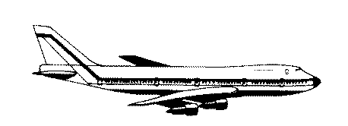

  - What is the height of the plane during take-off? Hint: During take-off, the plane hasn’t lifted off the ground yet.

  - What is the gravitational potential energy during take-off?

  - What is the kinetic energy during take-off?

  - What is the total energy of the plane during take-off?

  - What is the gravitational potential energy while cruising?

  - What is the kinetic energy while cruising?

  - What is the total energy of the plane while cruising?

  - So does Jessica’s plane have more energy during take-off or while cruising?

