J. M. Gabrielse | Date: 3/26/2006

- Unit: Electricity
Lesson: DC motors
______________________________________________________________________________
B. MSDE and BCPSS Standards

Maryland Core Learning Goals
- Goal 1: Skills and Processes
The student will demonstrate ways of thinking and acting inherent in the practice of science. The student will use the language and instruments of science to collect, organize, interpret, calculate, and communicate information.
- Expectation: The student will carry out scientific investigations effectively and employ the instruments, systems of measurement, and materials of science appropriately.
- Expectation: The student will show that connections exist both within the various fields of science and among science and other disciplines including mathematics, social studies, language arts, fine arts, and technology.
- Goal 5: Concepts of Physics
The student will demonstrate the ability to use scientific skills and processes (Core Learning Goal 1) to explain and predict the outcome of certain interactions which occur between matter and energy.
- Expectation: The student will know and apply the laws of electricity and magnetism and explain their significant role in nature and technology.
- Expectation: The student will show that connections exist both within the various fields of science and among science and other disciplines including mathematics, social studies, language arts, fine arts, and technology.

Project 2061 Benchmarks: 4G: The Physical Setting/Forces of Nature
- Grades 9-12: #5
Magnetic forces are very closely related to electric forces and can be thought of as different aspects of a single electromagnetic force. Moving electric charges produce electric forces. The interplay of electric and magnetic forces is the basis for electric motors, generators, and many other modern technologies, including the production of electromagnetic waves.
______________________________________________________________________________
C. Lesson Objectives:
- Students will build motors to demonstrate the interaction of electric and magnetic fields.
______________________________________________________________________________
D. Opening Activity/Drill
- As students enter: welcome them, and take attendance

- Drill:

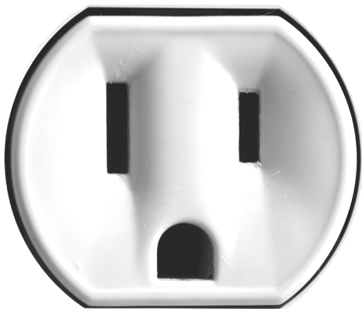
Match the hole to the description.

- ____ (1 pt) Ground, 0 V_{RMS}
A
B
- ____ (1 pt) Hot, 120 V_{RMS}
- ____ (1 pt) Cold, 0 V_{RMS}
C
- Electrons and holes make __________ fields.
- Magnets make ______________ fields.
- Moving electrons and holes also make ______________ fields.
- Moving magnets also make ______________ fields.
- Draw magnetic field lines around this magnet.

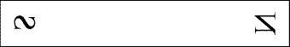

- Go over the drill.

Modifications: The drill we be on the board and read orally.
______________________________________________________________________________
E. Development
- Engagement of Students:
  - Yesterday we learned how electric motors work. Today we build them.

Modifications: Students are encouraged to ask questions.
______________________________________________________________________________
- Exploration Activities
  - Read the instructions.
  - Questions/Suggestions.

Modifications: The teacher will circulate reading directions and answering questions. Extra processing time will be allotted.
______________________________________________________________________________
- Explanation:
  - Materials will be reviewed, tool usage explained, and suggestions given.

Modifications: Students who need extra time will be given it. The instructions will be supplemented with teacher assistance. The notes are also available every day before and after school.
______________________________________________________________________________
- Extension
  - Test the motors.
  - Help classmates who are having trouble.

Modifications: Students who need extra time will be allowed it. Teacher assistance is available as time permits during class.
______________________________________________________________________________
- Evaluation/Assessment
  - Does the motor work?

Modifications: Students who require a modified work load will not be assigned all the questions. Additional teacher assistance will be provided
______________________________________________________________________________
- Closure
  - What parts do you need to make a motor?
  - Why were some motors better than others?
  - How do the motors work?

Modifications: Extra think time will be allowed for processing
______________________________________________________________________________
- Home Assignment
  - Explain how electric motors work in your own words. Include a diagram.
  - Study for the test (& make a 3” x 5” note card)

