J. M. Gabrielse | Date: 3/15/2006

- Unit: Electricity
Lesson: AC Circuits
______________________________________________________________________________
B. MSDE and BCPSS Standards

Maryland Core Learning Goals
- Goal 1: Skills and Processes
The student will demonstrate ways of thinking and acting inherent in the practice of science. The student will use the language and instruments of science to collect, organize, interpret, calculate, and communicate information.
- Expectation: The student will show that connections exist both within the various fields of science and among science and other disciplines including mathematics, social studies, language arts, fine arts, and technology.
- Goal 5: Concepts of Physics
The student will demonstrate the ability to use scientific skills and processes (Core Learning Goal 1) to explain and predict the outcome of certain interactions which occur between matter and energy.
- Expectation: The student will know and apply the laws of electricity and magnetism and explain their significant role in nature and technology.
- Expectation: The student will show that connections exist both within the various fields of science and among science and other disciplines including mathematics, social studies, language arts, fine arts, and technology.

Project 2061 Benchmarks: 4G: The Physical Setting/Forces of Nature
- Grades 9-12: #3 (selection)
A very small excess or deficit of negative charges in a material produces noticeable electric forces.
- Grades 9-12: #5
Magnetic forces are very closely related to electric forces and can be thought of as different aspects of a single electromagnetic force. Moving electric charges produce electric forces. The interplay of electric and magnetic forces is the basis for electric motors, generators, and many other modern technologies, including the production of electromagnetic waves.
______________________________________________________________________________
C. Lesson Objectives:
- Students will relate knowledge of DC circuits to AC circuits by using Ohm’s Law to solve AC circuit problems.
______________________________________________________________________________
D. Opening Activity/Drill
- As students enter: welcome them, and take attendance
- Drill:
  - Are ammeters used in series or in parallel? → series
  - Are voltmeters used in series or in parallel? → parallel
  - What is the voltage in this circuit? → V = I R = (0.08 A) (15 Ω) = 1.2 V
15 Ω
A I = 0.08 A
  - Where is the current highest in this circuit? → it is the same everywhere
50 Ω
9 V
40 Ω

- Go over the drill. Students will be asked to come to the board to do numbers 1, 5, and 6.

Modifications: The drill we be on the board and read orally.
______________________________________________________________________________
E. Development
- Immediate Feedback: Ohm’s Law II
- Engagement of Students:
  - You will be learning how the wiring in your house works.

Modifications: Students are given opportunity to ask questions.
______________________________________________________________________________
- Exploration Activities
  - Free Write: Tell me everything you know about electricity that comes out of the wall. Where does it come from, how does it get here, what is it, how does it make power tools do things, what do you do if the lights go off in a room…
    - The list of question prompts will be written on the board

Modifications: Students will work in collaborative groups. The teacher will field additional questions. Extra processing time will be allotted.
______________________________________________________________________________
- Explanation:
  - Notes: Alternating and Direct Current ← included in AC Electricity.ppt
    - A printable version is also included on p. 4
  - Demonstration: The instructor carefully (“You should never do this at home!”) measures the RMS-Voltage from a wall outlet.

Modifications: Students who need extra time will be given it. Students will work in groups. Teacher assistance is available as time permits during class and as needed every day after school.
______________________________________________________________________________
- Extension
  - Chapter 25 Practice Problems (p. 589): 5, 6, 7, 8
  - Read Glencoe Physics (p. 588 – 589): 25.1b (Alternating-Current Generator)
  - Play with magnets

Modifications: Students who need extra time will be allowed it. Teacher assistance is available as time permits during class. Modifications will be made to the worksheet according to individual need.
______________________________________________________________________________
- Evaluation/Assessment
  - Hand in the practice problems.

Modifications: Students who require a modified work load will not be assigned all the questions. Additional teacher assistance is available.
______________________________________________________________________________
- Closure
  - What kind of electricity comes out of a battery? ← DC
  - What does DC mean? ← direct current
  - What kind of electricity comes out of the wall? ← AC
  - What does AC mean? ← alternating current
  - What kind of electricity powers the radio in a car? ← DC

Modifications: Extra think time will be allowed for processing
______________________________________________________________________________
- Home Assignment
  - Read Glencoe Physics (p. 555 – 559): section 24.1a (magnets)
  - Chapter 24 Practice Problems (p. 560): 1, 2, 3

Electricity Notes (Continued):

- Alternating and Direct Current
  - Direct: one way
  - Direct Current (DC)
    - Current always travels in the same direction
    - Batteries provide DC voltage
  - Alternate: to take turns, to go back and forth
    - Current switches directions (back & forth)
    - Wall outlets provide AC voltage
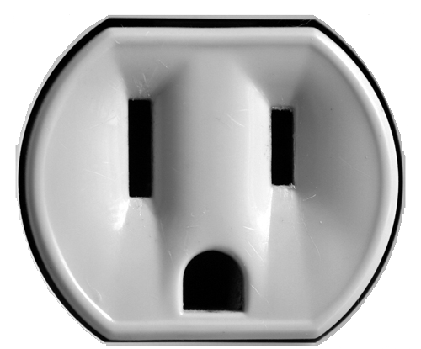
Neutral →
← Hot
← Ground
    - AC voltage and current is measured using root, mean, square (RMS)
      - RMS voltage gives you the “effective” voltage
  - Power (P)
    - P = IV = I²R

