Name: _________________
Date: _________________

Static Electricity

- What is a negative charge?

- What is a positive charge?

- Who picked the names negative and positive?

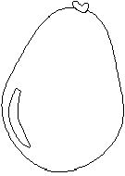
- All of these balloons have net charges of positive or negative 1. Draw arrows showing where each balloon is attracted or repelled.
+
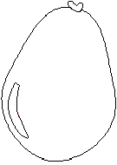
-

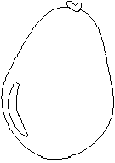
-
+

- Draw 6 charges on the end of a rubber rod after it is rubbed with a felt cloth.

- Draw 6 charges on the end of a glass rod after it is rubbed with a silk cloth.

- Draw positive and negative charges on the balloon and on the cloth.
  - In the before picture draw no more than eight charges.
  - In the after picture draw the same charges wherever they ended up.
  - Write the net charge for each object in the before and after pictures.

Before they are rubbed. | After they are rubbed.
net charge ____ net charge ____ | net charge ____ net charge ____

