Name: _________________
Date: _________________

Magnetic Fields

- Magnets have two ends (poles). What do we call them?

- What kind of field does a magnet make?

- What kind of field do electrons and holes make?

- How are electric and magnetic fields related?

- Draw magnetic field lines around this magnet.

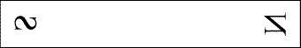

- What do electrons and holes make only when they are moving?

- What do magnets make only when they are moving?

Figure 1 | Figure 2
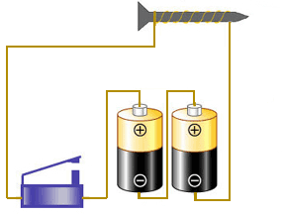 | 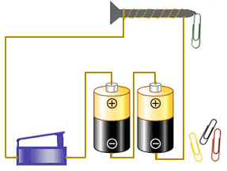

- Why are the paperclips attracted to the nail in Figure 2 but not in Figure 1?

- For each picture, draw arrows showing how the magnets would get pushed and pulled.

N  S  N  S | N  S  S  N
N  S  N  S | N  S  S  N

- How do you know moving electrons make magnetic fields? Your explanation should include a picture.

- How do you know moving magnets make electric fields? Your explanation should include a picture.

