Name: _________________
Date: _________________

Circuits
Matching:
- _____ voltage source  - _____ resistor  - _____ circuit | - a loop/path that charges can move through  - something that it is hard for charges to move through  - what makes charges move

- Is it harder for charges to move through a glass rod or an aluminum rod?

- What is an example of a voltage source?

Figure 1 | Figure 2
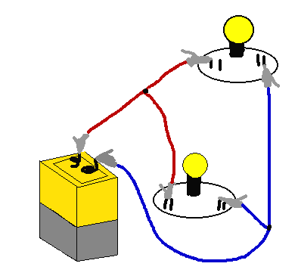  1  2 | 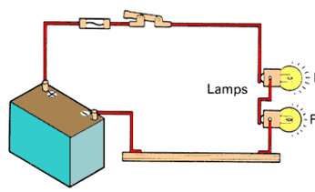  3  4

- Light bulb 1 in Figure 1 is unscrewed.
  - Is there still a loop that charges can travel through?

  - What happens to light bulb 2?

- Light bulb 4 in Figure 2 is unscrewed.
  - Is there still a loop that charges can travel through?

  - What happens to light bulb 3?

- Why do circuits have to be loops?

Circuit 1 | Circuit 2 | Circuit 3
A  B | A  B | 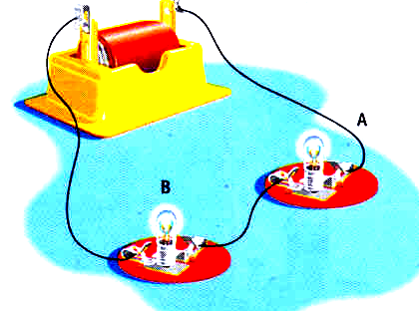
Circuit 4 | Circuit 5 | Circuit 6
A  B  C | L  R  B  A | 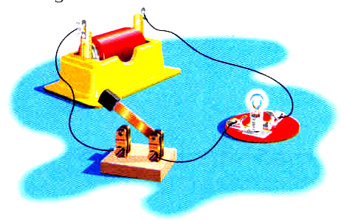

- What is wrong with Circuit 6?

- Which circuits (1, 2, 3, 4, 5, 6) have light bulbs in series?

- Which circuits (1, 2, 3, 4, 5, 6) have light bulbs in parallel?

- Which two circuits are just different ways of drawing the same thing?

- In Circuit 5:
  - Which direction (left or right) do the holes flow out of the battery?

  - Which direction (left or right) do the electrons flow out of the battery?

- Draw a circuit with two light bulbs. If one light bulb burns out the other one must stay on.

- Draw another circuit with two light bulbs. If one light bulb burns out the other one must turn off.

